Music proposal – Samantha and Alister
Your wedding is an intimate reflection of you and as such requires musical and creative attention. To authentically convey that feeling to the guests sharing in this momentous day, your musical input is invaluable.
Over the next months, we’ll be working with you on your wedding soundtrack. Building on our experience of what works and what doesn’t, we’ll guide you in the repertoire selection process from guest arrivals to closing song.
Most of the suggested acts below are open to learning new repertoire, so if you’ve got something specific in mind, let us know. While we’ll try to our best to accommodate you, we’ll also be honest when we feel something won’t work musically or is not possible.
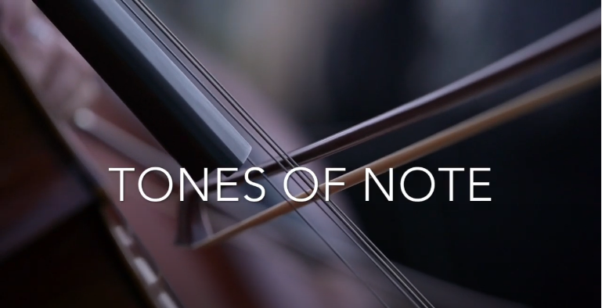

Guest arrivals: The celebratory sound of the Il Afro Suns marimba band will welcome guests as they arrive at the Manor House, entertaining while they get a drink and catch up ahead of the ceremony. Once the ceremony has been concluded, Il Afro Suns make a surprise return and lead guests from the ceremony area to the pre-drinks area.
Ceremony: Reflecting the intimate ceremony you envision, we suggest keeping the entertainment here minimal by featuring a solo singer + guitarist. Given that you’re leaning in the direction of Kina Grannis’ version of Can’t Help Falling in Love, here are two performers, whose vocal style fits this song beautifully.
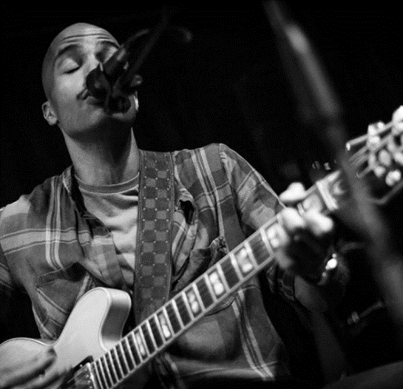
Option one: Ethan Florus
Reinterpreting a range of songs from Drake’s Hot Line Bling to Alicia Key’s If I Ain’t Got You, Ethan is known for his smooth vocals and deft guitar playing.
He developed his vocal and guitar skills during the 5 years he spent at the Stellenbosch University Konservatorium. He drives his passion for the art by sharing his skills through teaching, and his music through performing and recording.

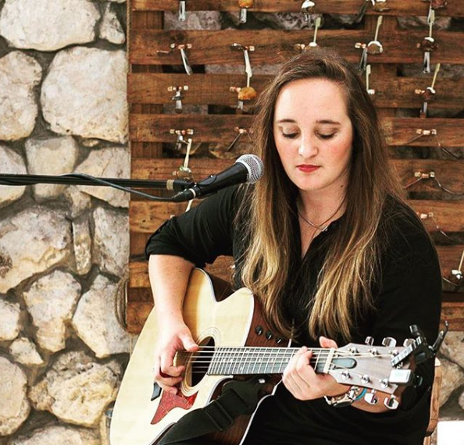
Option Two: Lize Mynhardt
Lize Mynhardt is a gifted, driven, and influential musician, spending the last decade writing and releasing her own songs. Born in Cape Town, South Africa, Lize was blessed with perfect pitch and has mastered seven instruments excluding her voice, making her a unique artist.
She has released 9 songs, a Christmas album in aid of Pebbles Project charity, and has collaborated with a diverse group of other artists including DJ Cosher, Howard Edward, DSB, DJ Qness, Ben Ludik and producers from Nashville.

Pre-drinks: DJ + Option of live instruments
A DJ is a good alternative to a live performer for pre-drinks, with the music during this period setting the tone for the rest of the night. Musically speaking, DJs have a broader range of styles and songs to choose from, allowing them to take the music where the guests want it to go. Ultimately this set must be upbeat, featuring songs that appeal to the majority of your guests while also representing your musical preferences.
This is achieved by playing a mix of classics from soul, jazz, and current popular music. To find out which songs from those genres most resonate, we’ve included a 90-minute sampler below. Please give it a listen and send us your feedback. We’ll use that to curate the set.
Rus Nerwich - Playlist Sampler
Additional options include the following:
- Rus Nerwich to play saxophone on selected tracks.
- Trumpet play to perform during the pre-drinks set.
- Percussionist to perform during the pre-drinks set.

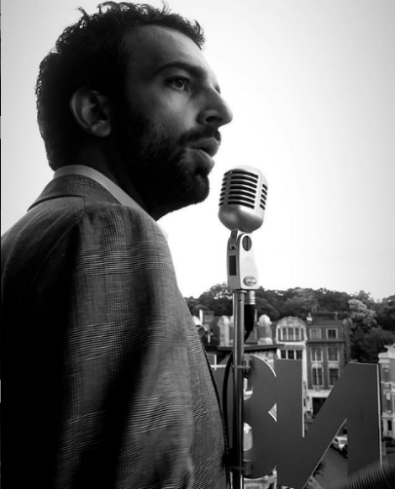
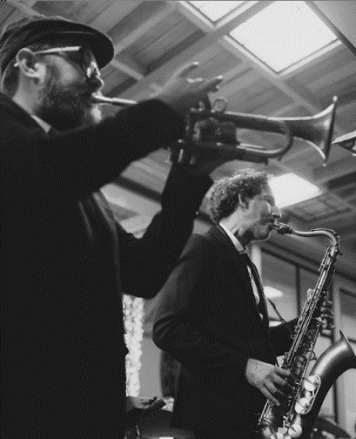
Dinner: As the doors to the reception area are opened and the dinner and dance area are revealed, guests are greeted by Francesca Biancoli and a 4-piece jazz quartet. Over the course of dinner, Francesca and Nathan will take the stage performing a range of Bossa Nova and Crooner style songs.
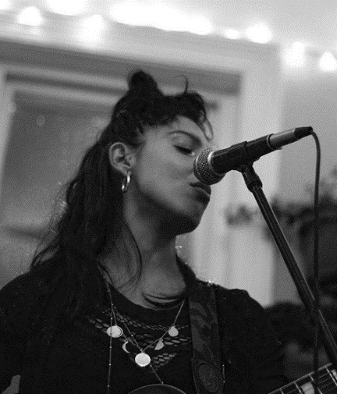

Dance: Directly following the first dance, vocalists Nathan Ambach and Francesca Biancoli lead this 8-piece band including keys, bass, guitar, saxophone, trumpet and drums to perform high-energy dance set opening the dancefloor. Touring and performing together for the last 6 years, Rus Nerwich and Nathan Ambach (N8N) have developed an electric onstage chemistry, offering clients an all-inclusive musical solution.
Both Nathan and Rus bring together 20 years of musical and performance experience. From world-class live performances of quintessential classics covering soul, funk, blues, pop and jazz to a dance till you can’t dance no more DJ set, you are guaranteed one of the greatest parties of your life!
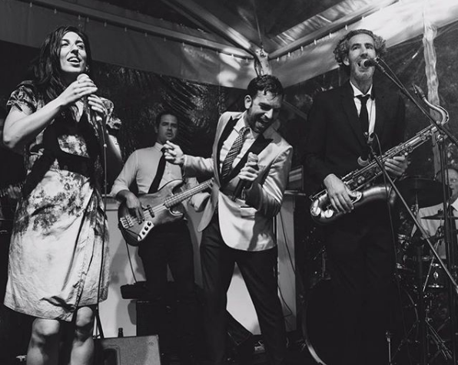

For more videos of the band’s past performances, please see the following links:

Instagram - Starlight Band - Prince - Kiss
Instagram - Starlight Band - Prince - Kiss (2)

Party: In 2006, in his hometown of Antwerp, Nathan launched the nightlife series: The Love Below as ‘Your Monthly Rendezvous with Soul’, where he is still the resident DJ + promoter of funky music worldwide!
He’s DJ’d alongside Mark Ronson at the WMC in Miami and played at the Love Below with DJ Jazzy Jeff (The Fresh Prince), DJ Premier, DJ Maseo (De La Soul), and DJ Rashida – the official tour DJ of Prince and Bruno Mars and DJ'd sets in clubs and events around Europe, America, Asia, Africa and the Middle East.
His Spotify playlists and online mixtapes represent his funky style, championing soulful music with great grooves and party hooks. For over 20 years, N8N has been rocking the business from BBQs to Bar-Mitzvahs!
N8N - The DJ Side of the Story

